Assignment – 15 (Subqueries with DML Commands)
1️.Write a command that inserts into the table Multicust all salespeople who have more than one customer. The table Multicust has the same columns as the Salespeople table.
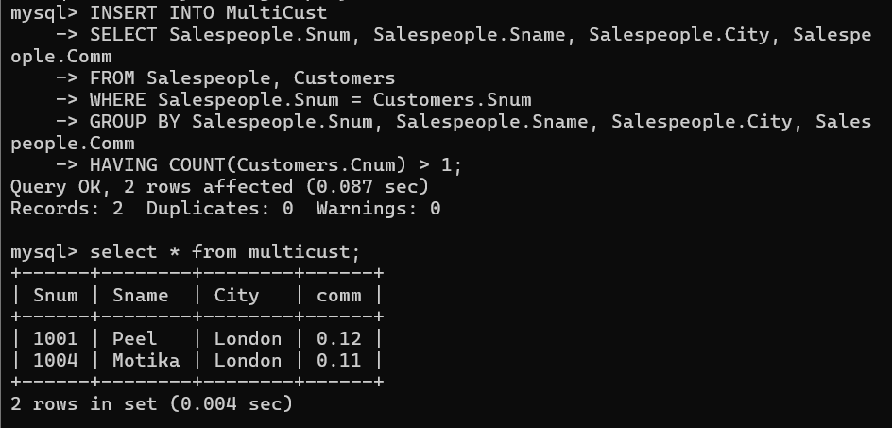
2️.Write a command that deletes all customers who do not have any current orders.
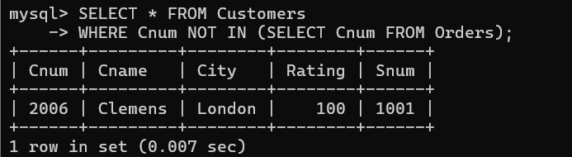
3️.Write a command that increases the commission of every salesperson by 20% if their total order amount is greater than Rs. 3,000.

